CUT&RUN Processing
CUT&RUN Pipeline Commands
General linux commands:
- “cd” will change the directory to wherever you want to go
- “ls” will list all the files/directories in the current directory that you’re in
- “pwd” will show you the entire file path for the directory you’re currently in
- “cntrl c” ends any command that is in process
- “ls -l” give u more info about a file and file size
- “rm” deletes files
- “cp” copy
- “vim” to go into a script/or view a script
- “cd ..” is to go backwards (out of 1 directory)
- “df -h” is to find the statistics of the server (useful when you think there is no space. Check ‘data’ category)
- “clear” will clear the screen
- “mkdir” - make a new directory
- cp <from path> <to path>
- mv <from path> <to path>
Script Editor: (press “esc”) first
- “G” to go to bottom
- “gg” to go to top
- “ZZ” to exit vim and save and quit
- Shift “I” how you change/edit the script
- Esc-button – exits the edit mode
- “:q!” exit vim without saving
Screen:
- “screen -S“ then a screen name to create a new screen
- ctrl a + d to detach from screen
- ctrl a + k → y to kill a screen
- “screen -ls” to list a screen
- “screen -r [screen.name]” to reattach the screen
  - If multiple screens and want to reattach, then have to type in the full name
- “screen -x [screen.name]” to view attached screen
- “screen -S [screen.name] -X quit” to kill a specific screen

Other ground rule:
- Do not change any of the current conda environments without asking the channel first (i.e. install/update new packages). If you’d like to tweak the environment, just copy it over to a new one

Sequencing data is available on the FTP server (will be sent out by Cole) in a link like this: e.g.
ftp://igm-storage2.ucsd.edu/20230929_LH00320_0051_B22CYMFLT3/

FTP Login
Username:
ferguson
Password:
bjHl5OPB3C

Before Starting (only need to do the first time):
- Download the PEM key (get it from someone who has it and store it in a folder).

Login on AWS:
- Login on AWS
- Sign in using IAM login
  - Account Number: 433642023207
  - Username: FirstnameLastname
  - Individual Accounts
- KellyWang
- au0Cu0)0
- Click on EC2
- Go to Instances (running)

Root user login:
- Username:
cferguson@health.ucsd.edu
- Password:
OKMbhuTFC47$&
^ not used for access to AWS as of 2025

Entering the Instance
- Open terminal on your computer.
- On terminal, change the directory to wherever the PEM key is:
  - cd [DRAG AND DROP FOLDER W/KEY]
  - hit enter
- If there is error with the key, type “chmod 400 ./210323.pem” then enter
- In the next line, enter “ ssh -i ./210323.pem ubuntu@ec2….com ”
  - Copy the “ec2…” address on AWS.
  - The ec2 address will change after every time someone starts and stops the instance
  - After the “@” is where you paste the new/public ec2 address.
  - Change according to the ec2 line above, copy up to com.
  - Select “yes” to continue connecting.
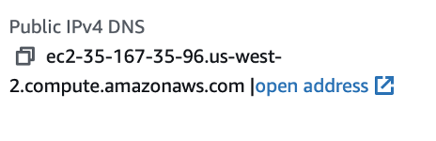

Manual Method
Use this GitHub Gist to ssh into the instance automatically: https://gist.github.com/Zaki-1052/11d24acf7eed6ef145a392e2980b8222
GENERAL NOTES:
- For each command that you run, make sure your computer screen does not shut off in between. If it does your files will look like they are processing, when in reality they are not.
- Change the settings on your computer so that your screen never turns off when processing CUT&RUN files.
- ^If you aren’t running on a screen, you will need to keep your laptop screen open/on (or connected to the wifi to ensure the data processes). The aforementioned does not apply if you are running a screen instead

STEP 1: Import fastq files into the instance:
ATAC-seq steps in blue if using Nextera primers
- To import files into the instance, you have to be logged out of the instance
  - To logout type “logout”
- The import command is “ scp -r -i ./210323.pem ‘path/to/fastq file’ ubuntu@ec2-35-88-77-234.us-west-2.compute.amazonaws.com:/data/rs_256/fastq/ “ slash = important
- Can list multiple files + make sure to put spaces in between the names.
- Directory for mouse samples: /data/rs_256/fastq/
- Directory for human samples: /data/rs_256/human_fastq/
- Directory for ATAC-seq mouse samples: /data/rs_256/atac_fastq/
- All the files will say “100%” when done being imported.
- Log back into the instance with: “ ssh -i ./210323.pem ubuntu@ec2….com ”

Import directly from IGM FTP server to instance
- Install Homebrew (one-time installation) by running “/bin/bash -c "$(curl -fsSL https://raw.githubusercontent.com/Homebrew/install/HEAD/install.sh)" “
  - May request password for computer.
    - You will not be able to see you typing. Just enter the password and hit Enter
- Run “brew install wget” and “brew install lftp”
- - Run these commands in your terminal
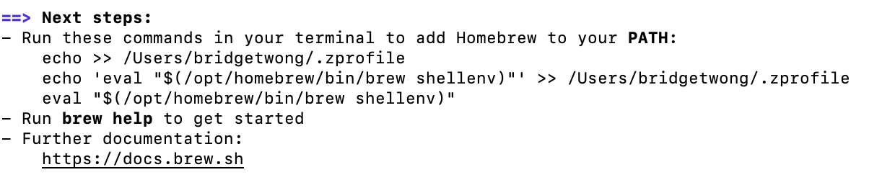
- Log into instance as normal.
- Run “sudo apt-get install lftp”
  - To access IGM server from instance
- Run “lftp -u username,password ftp server”
  - Ex. “lftp -u ferguson,bjHl5OPB3C ftp://igm-storage.ucsd.edu/250423_LH00444_0330_A22YW7JLT3/”
  - Will see the following
- Use mget and list all files desired separated by a space
- Type bye to leave lftp. Will return to instance again. Check for files and mv to appropriate directory if necessary

Import from harddrive to AWS instance:
EXAMPLE: /Volumes/2/260406_Jai_MeCP2_adult_fastq/* ubuntu@ec2-54-244-37-255.us-west-2.compute.amazonaws.com:/data2/rs_256/fastq/

Note: if the hard drive has spaces in the folder or other weird symbols like “#” or “$”, you need to rename it without those. But once you finish upl

STEP 1.5: fastQC
- Create a new folder corresponding to where you would like all the QC files to go – i.e. “fastQC_reports”
- Run “fastqc -o fastQC_reports inputfile.fastq.gz” for an individual file or “fastqc -o fastQC_reports *fastq.gz” for all the files at once. It should take around 2-3 minutes to process each fastq file
- To collect these into a combined report, “conda activate base” then “multiqc fastQC_reports”

STEP 2: Create a link between the working directory and the fastq directory.
All the files are stored in the fastq directory but we all the commands are run in the working directory and therefore, we need to create a “link” between the 2 directories so that we can use them

- Go to “ ~/cutruntools ” directory
  - For mouse samples, run: “ ./create_scripts.py config2.json ”
    - “config3.json” if working in data2
  - For human samples, run: “config_human.json”
  - This creates the link and you should then see your fastq files appear in the /data/rs_256/workdir/ directory for mouse. For human, the files should appear in the /data/rs_256/human_workdir/
  - For ATAC-seq samples, run: “./atac_create_scripts.py config_atac.json

STEP 3: Part 1 of Pipeline: Align and Trim Fastq Files to Make BAM files.
- Go to “ /data/rs_256/workdir/” directory
  - ATAC - “/data/rs_256/atac_workdir/” directory
- Run “ ./integrated.sh ‘fastq_R1’
  - There are 2 fastq files for each index
  - Just copy and paste the one that says R1 after the integrated.sh command
- Once the files are done running, the command line following will be green and purple.
- Best to run all the samples before moving to the next step.
- DO NOT DELETE THE BAMS in the Sorted folder!!! You need them for diffbind in stage 2!!

STEP 4: Part 2 of Pipeline: Generate Bigwigs from BAM files.
- Go to the “/data/rs_256/workdir/aligned.aug10” directory if mouse.
  - If human, go to “/data/rs_256/human_workdir/aligned.aug10”
  - If ATAC, go to “/data/rs_256/atac_workdir/aligned.aug10”
- Run “conda activate”
- Run “ ./create_bams.sh ”
  - Hit enter
  - Then enter the bam files that you want to process. Enter after every file.
  - If you have no more then type “N” and it will start processing
  - Log out

STEP 4: Export the files
This will export just the norm files.
- Log out of the instance (type logout)
- Type in: “ scp -r -i ./210323.pem ubuntu@ec2-35-167-35-96.us-west-2.compute.amazonaws.com :/data/rs_256/workdir/aligned.aug10/name of sample that ends with.bw . ”
  - Make sure that the ec2 address is the current one.
  - Change the “:/data/…” part to wherever the file is actually located. (i.e. if it is located in human directory, change it so what it is human_workdir)
  - AFTER THE BW FILE, MAKE SURE THAT IT IS “.bw[space].[space] “ → enter

STEP 5: Roman Normalization (produce .rnorm files)
Note: Only works for mouse samples. NOT HUMAN
- Log back into instance (use “ ssh -i ./210323.pem ubuntu@ec2….com ”)
- Go to “ /data/rs_256/workdir/”
- Run “ ./integrated.step2.sh “file name (bam file)”
  - This command will produce bigwigs files that are located in one of the macs directory.
  - According to Leya, you don’t actually have to do this step to roman normalize because the “ ./create_bams.sh ” script produces the same exact bigwig in the aligned.aug10 directory. Therefore, you can probably skip to save time (unless you want to rerun it).
If skipping “ ./integrated.step2.sh “file name (bam file)”, then do the following.
- Move (or copy) the bigwig files from the aligned.aug10 directory to the “/media/rs_256/normalization” directory
  - Type the following:
“ mv /data/rs_256/workdir/aligned.aug10/filename.txt /media/rs_256/normalization/ ”
  - Check to make sure they are in the “/media/rs_256/normalization/” directory
- Change directory to: /media/rs_256/normalization
- Change directory to: master_files
- Open: vim normalization.r
  - Type E to edit the script.
- Edit “normalization.r” script so that samples listed is your samples and remove the “.bw”
- When normalizing 4 samples, all will be normalized to the first sample listed for the same histone modification.
- Don’t include .bw
- Exit and Save the normalization script.
- Run “conda activate bwnorm” in “media/rs_256/normalization/master_files”
- Run script via “ Rscript normalization.r ”
- Exit the conda via “conda deactivate”
- Logout
- Export the files (see above) and change to correct directories.
  - Type in: “ scp -r -i ./210323.pem ubuntu@ec2-35-167-35-96.us-west-2.compute.amazonaws.com :/media/rs_256/normalization/name of sample that ends with.bw . ”
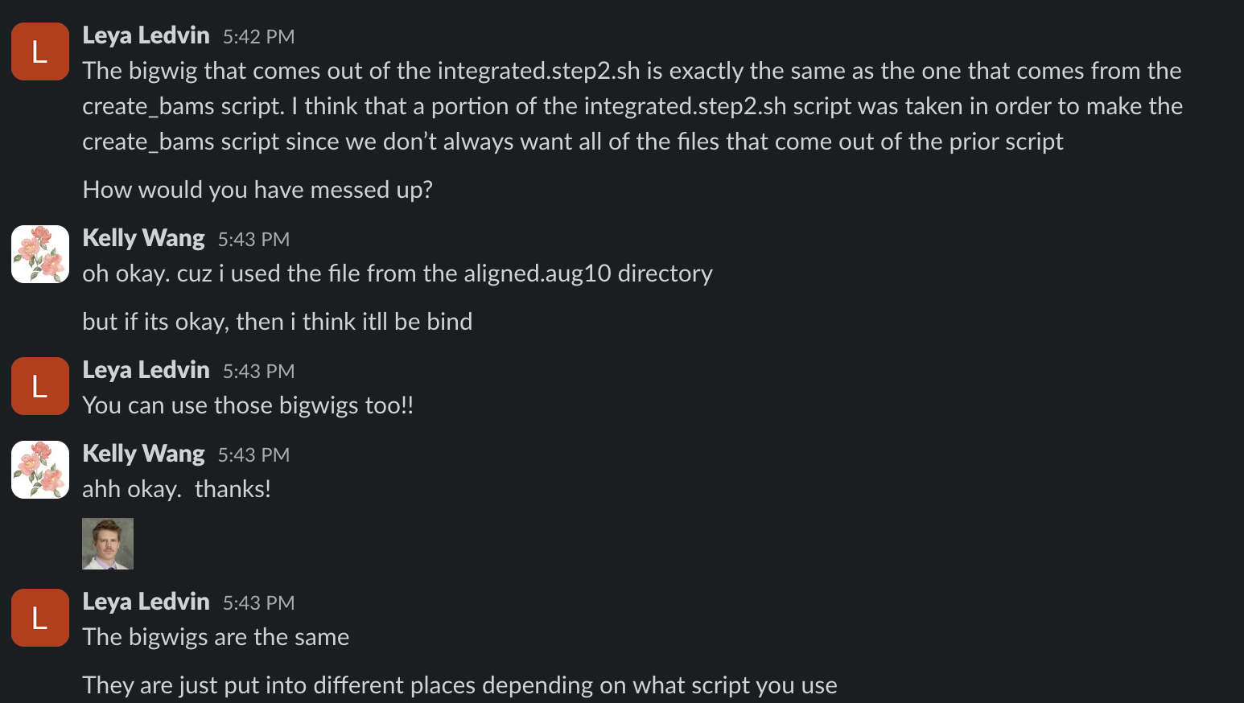

STEP 6: STOP THE INSTANCE
EXTREMELY IMPORTANT: DO NOT TERMINATE THE INSTANCE. NEVER CLICK TERMINATE THE INSTANCE. YOU WILL DIE
- Instance run = money, so when done, stop the instance.
Before stopping the instance, do the following:
- Log back into the instance with: “ ssh -i ./210323.pem ubuntu@ec2….com ”
- Check the number of USERS logged in:
  - 1 means another person is in it
  - 0 means that you are the only one in the instance.
- If there is 0, proceed to stopping the instance. If there is 1 don’t stop the instance (otherwise the files the other person is processing will not work).
- To stop the instance, go back to the AWS page (the one that you logged in online).
- Go back to the page where you found the ec2 address and click on “instance state” at the very top.
- Click on “stop instance”

STEP 7: Make space in instance.
- Clear out unnecessary files
- Can run AP’s script
- If doing manually, remove the following files:
  - Files in “trimmed”
  - Files in “trimmed3”
  - .bai files
  - sorted bam files
  - old files
  - Remove fastq and BAM files because they take up a lot of space

Troubleshooting
- It is helpful to type in “ls -lh” after you make the bam files and check to make sure the file sizes seem normal. They should be very big. If they are not big, delete and re-run them. Your file may be truncated and not work.
- Before you run the script, make sure there is enough space on the instance. If there is not enough space, your files will not store and you will need to re-run. Check df-h under “data” to see what percentage of the instance is occupied.
- If you are processing human fastq files, and nothing seems correct, enter the integrated.sh script and make sure the reference genome is correct for humans. It should be “hg38” if it doesn’t say that, edit the script.
- IF SAMPLES SEQUENCED ON SEPARATE LANES, CONCATENATE THE FASTQ FILES AS FOLLOWS
  - cat yoursamplename_*_R1_*.fastq.gz > yoursamplename_SXX_cat_R1_001.fastq.gz
  - cat yoursamplename_*_R2_*.fastq.gz > yoursamplename_SXX_cat_R2_001.fastq.gz

AP’s Modifications
Note: press <tab> to autocomplete the file name // list any similarly named files in terminal)
AP’s Script(s):
(as an argument to the actual command - use the FASTQ R1 file name without file path)
(e.g. – 230815_index_15_R1.fastq.gz)

Human Bigwigs -
conda activate
cd /media/rs_256/ap_tests/
bash ap_human_generate_bw.sh <R1 fastq file>

Mouse Bigwigs -
conda activate
cd /media/rs_256/ap_tests/
bash ap_generate_bw.sh <R1 fastq file>

Mouse bed files -
conda activate
cd /media/rs_256/ap_tests/
bash ap_bed_files.sh <R1 fastq file>

Normalization –
cd /media/rs_256/normalization/master_files/
Rscript input_normalization[AP1] .r

Once done processing (to clear up space and remove all irrelevant files) –
Note - Make sure to save the files to your computer before removing them from the server.
To remove FASTQ files:
bash ap_remove_files.sh <full FASTQ file>
To remove BED files:
bash ap_remove_bed.sh <full FASTQ file>

Bonus tips -
For letting a time-consuming terminal process run in the background –
Add “nohup[AP2] ” in front of the command, and
Add “ > file1.txt” or any similar file name to the end[AP3]
e.g. – nohup bash ap_generate_bw.sh 230815_index_15.fastq.gz > nohupindex15.ctxt
On the terminal, you can create multiple terminal tabs using Cmd+t and use the key combination “Cmd”+”1” to go to the first tab, and “Cmd”+”2” to go to the second tab, etc.

Stage 2

STEP 5: Peak calling
Note: Only works for mouse samples. NOT HUMAN
- Log back into instance (use “ ssh -i ./210323.pem ubuntu@ec2….com ”)
- Go to “/data/rs_256/workdir/” or “/data2/rs_256/workdir/”
- Run “ ./integrated.step2.sh “file name (bam file)” using the unsorted bam file
  - This command will produce bed and bigwigs files that are located in one of the macs directory.
  - This will perform peak calling with both MACS2 narrow and broad formats as well as SEACR algorithms
  - “Dedup” folders will contained files with removed PCR duplicates, which should be used, “all.frag” folders contain
- So far, here’s what works best:
  - SEACR stringent for most CUT&RUNs (*.stringent.sort.bed)
  - MACS2 narrow for H3K4me1 (*.narrowPeak)
  - MACS2 narrow for ATAC-seq (*.narrowPeak)
  - MACS2 broad for Me-CUT&RUN (*.broadPeak)

- To subtract blacklisted regions, copy the bed files of interest into “/data/rs_256/workdir/blklist_subtract/to_subtract”
- Run “./subtract_blacklist.sh”
- Blacklist-subtracted bed files will populate in the “data/rs_256/workdir/blklist_subtract/subtracted_bedfiles” directory

Functional Annotation (Note: this is much easier done on Rstudio with SubsetbyOverlap and AnnotatePeaks) - RETIRED
- “Bedtools intersect -a [file1.bed] -b [file2.bed] > overlappingpeaks.bed” to find overlap between replicates
- “annotatePeaks.pl [intersected_file.bed] mm10 -annStats [distribution.txt] > annstats.txt” to capture annotation statistics in addition to peak files
- “annotatePeaks.pl [intersected_file.bed] mm10 -go > go.txt for GO enrichment addition
- “Bedtools subtract -a [overlappingpeaks.bed] -b [blacklistedpeaks.bed]” to remove blacklisted regions
  - Or place all files to be subtracted in “to_subtract” directory then run “./subtract_blacklist.sh” and files will be in “subtracted_bedfiles” directory

Genome-wide heatmaps
- cd /data2/rs_256/genomewide_plots/
- Script: ap_refpoint_heatmap2.sh
- Recommended to run this on a screen as it will take long!!
- Conda activate deeptools_env (or create a copy of this environment with your own name).
- Run script: ./ap_refpoint_heatmap2.sh
- Will ask you to enter the number of controls and mutants you have.
- Then separately, it will ask you to provide the path to each sample’s normalized bigwig file.
- Next, it asks you to enter your summit bed files. This can be an A or B compartment file.
- Enter the histone modification you are interested in. (Type the name) This should not be a file. It simply needs the name of the modification to title the graphs.
- Enter the directory where you want to save the heatmap.
- Hit return to run!

Differential Peak Analysis
- Before running, make sure of the following:
  - Both SORTED bam files with accompanying .bai index files are in the instance
  - Blacklisted regions are subtracted from .bed peak files and are in the instance
- A sample sheet is required for this to run in the instance. This should be a csv with the following columns:
  - SampleID - name of each sample. For your own sake, be sure this specifies age and genotype
  - Factor - name of TF/HM used in C&R
  - Condition - specify “ctrl” or “mut”
  - Replicate - number in order, be sure each ctrl-mut pair is assigned a different replicate number
  - bamReads - location of sorted
  - Peaks - the blacklist-subtracted peak file location
  - Peakcaller - “bed” for every sample
Be sure there are no additional rows in your csv file, this will confuse the code and make that there are additional unassigned samples
So like this:
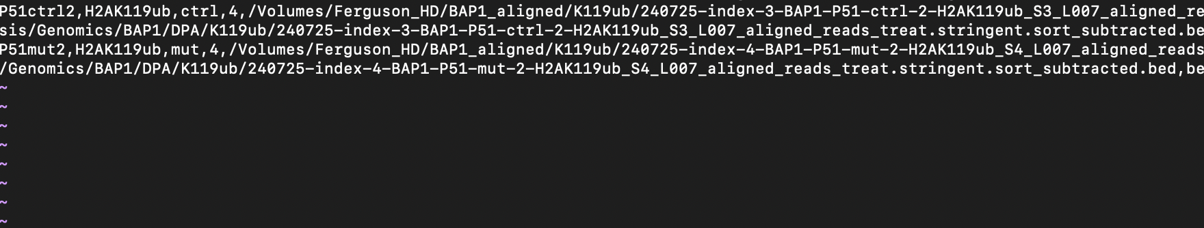
Not this:
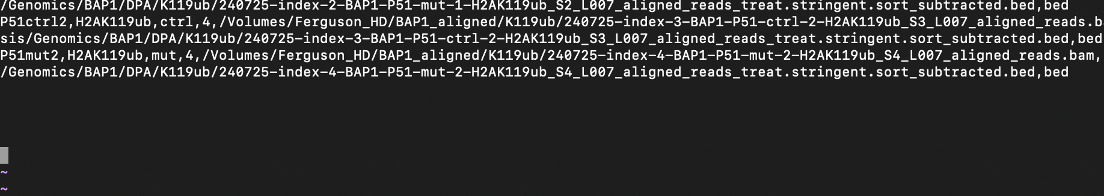
- “conda activate diffbind”
- “cd /data2/rs_256/workdir/DPA/”
- Rscript diffbind.R [experiment_name] [samplesheet.csv]
- This will run diffbind and load the outputs into a folder titled with the specified experiment name
- 250504 - as of now, the top row doesn’t have the expected rownames. Will fix later, but this has to be added at the top of the txt file for column names
- If running on a consensus peakset, then remove the Peaks and Peakcaller columns and run Rscript diffbind_peaklist.R [experiment_name] [samplesheet.csv] [peakset.bed]

Cistrome Analysis
- Save the up.bed and down.bed files from the diffbind secondary analysis R script
- Upload them to http://dbtoolkit.cistrome.org/ here: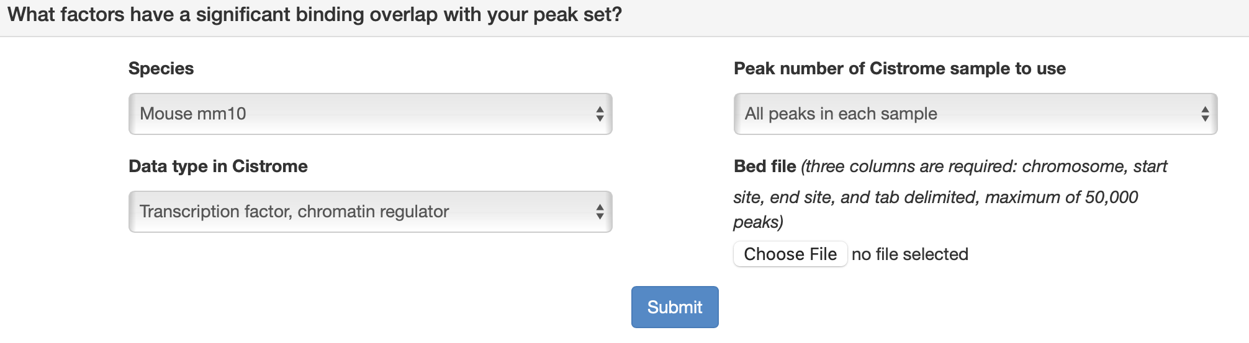
- Set data type to either run TF or HM – both are informative.
- Output should look something like this:
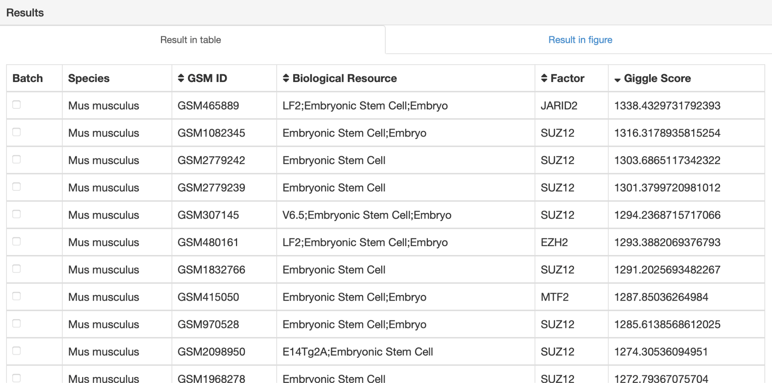
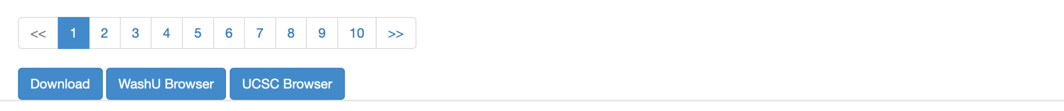
- Hit “download” at the bottom and save your file as your bed file + HM or TF to specify (i.e ‘H2AK119ub_up_HM.csv’)
- Open up the csv file in excel
- Add a new empty column for “Biosource_group”
- Copy and paste the following into the value for that row, then drag and drop:
=IF(OR(ISNUMBER(SEARCH("cerebellum", C2)), ISNUMBER(SEARCH("cerebellar", C2))),
"Cerebellum",
IF(OR(
ISNUMBER(SEARCH("embryonic stem", C2))
), "ESC",
IF(OR(
ISNUMBER(SEARCH("neural progenitor", C2)),
ISNUMBER(SEARCH("neural crest", C2)),
ISNUMBER(SEARCH("neuronal progenitor", C2)),
ISNUMBER(SEARCH("neural stem", C2)),
ISNUMBER(SEARCH("neuronal stem", C2))
), "NPC",
IF(OR(
ISNUMBER(SEARCH("brain", C2)),
ISNUMBER(SEARCH("cortex", C2)),
ISNUMBER(SEARCH("neuron", C2)),
ISNUMBER(SEARCH("hippocampus", C2)),
ISNUMBER(SEARCH("olfactory bulb", C2)),
ISNUMBER(SEARCH("striatum", C2)),
ISNUMBER(SEARCH("midbrain", C2)),
ISNUMBER(SEARCH("forebrain", C2)),
ISNUMBER(SEARCH("hindbrain", C2)),
ISNUMBER(SEARCH("cranial", C2)),
ISNUMBER(SEARCH("nucleus accumben", C2)),
ISNUMBER(SEARCH("dendritic", C2)),
ISNUMBER(SEARCH("ganglionic eminence", C2)),
ISNUMBER(SEARCH("astrocyte", C2))
), "Other Brain", "Other"))))
- Output should look something like this:
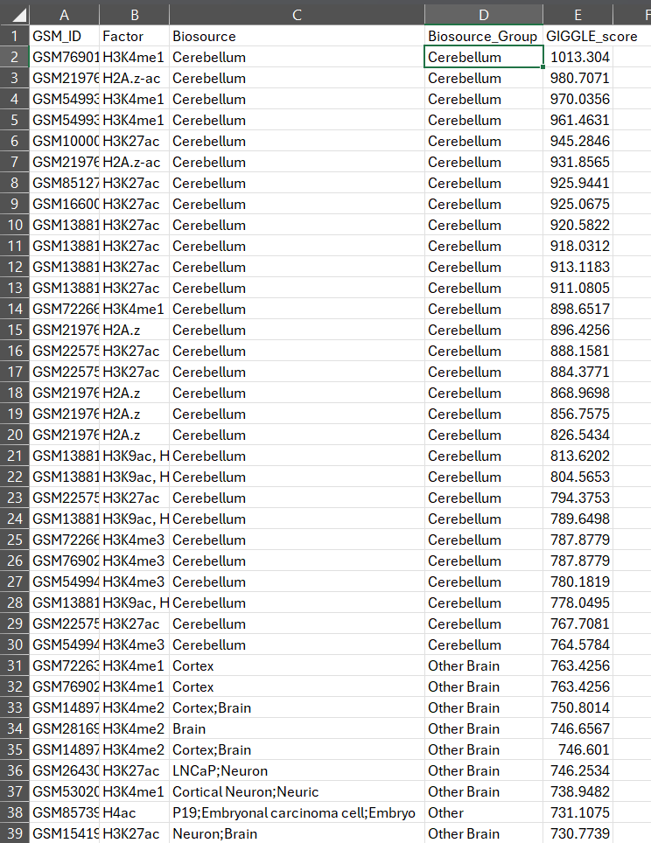
- Now run this code in R – change the name and modifications as needed:
> H2AK119ub_UP_HM ← import.csv(H2AK119ub_UP_HM.csv, header=TRUE)
> ggplot(
+ H2AK119ub_UP_HM %>%
+ semi_join(
+ H2AK119ub_UP_HM %>%
+ group_by(Factor) %>%
+ summarise(max_score = max(GIGGLE_score), .groups = "drop") %>%
+ arrange(desc(max_score)) %>%
+ slice_head(n = 10),
+ by = "Factor"
+ ),
+ aes(
+ x = fct_reorder(Factor, GIGGLE_score, .fun = max, .desc = TRUE),
+ y = GIGGLE_score,
+ color = Biosource_Group
+ )
+ ) +
+ geom_jitter(width = 0.1) +
+ scale_x_discrete(expand = expansion(mult = c(.25, .25))) +
+ scale_color_manual(values = c(
+ "ESC" = "#FFD700",
+ "NPC" = "#01CEFC",
+ "Cerebellum" = "#FF0000",
+ "Other Brain" = "#00CC66",
+ "Other" = "#9900FF"
+ ), drop = FALSE) +
+ labs(
+ title = "H2AK119ub_UP_HM",
+ color = "Biosource Group",
+ x = "Factors"
+ ) +
+ theme(axis.text.x = element_text(angle = 90))

Misc:
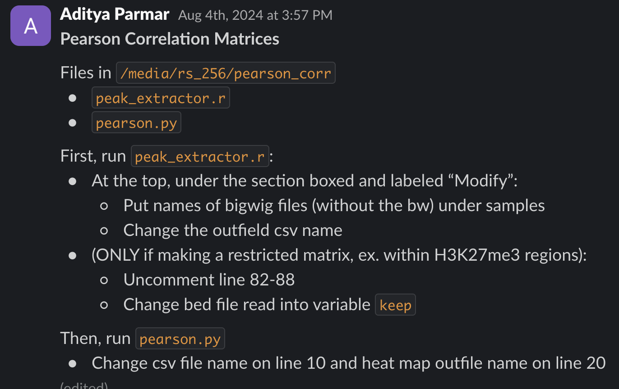

Helpful file locations:
- Assemblies for mm10 are already in ~/cutruntools/assemblies/chrom.mm10
  - No need to reupload for other purposes

